HTTP (Hyper Text Transfer Protocol)->

The Hypertext Transfer Protocol (HTTP) is application-level protocol for collaborative, distributed, hypermedia information systems. It is the data communication protocol used to establish communication between client and server.

HTTP is TCP/IP based communication protocol, which is used to deliver the data like image files, query results, HTML files etc on the World Wide Web (WWW) with the default port is TCP 80

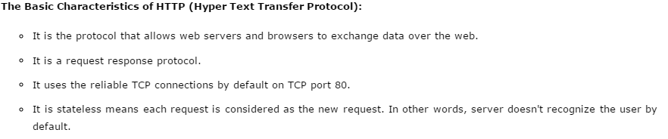

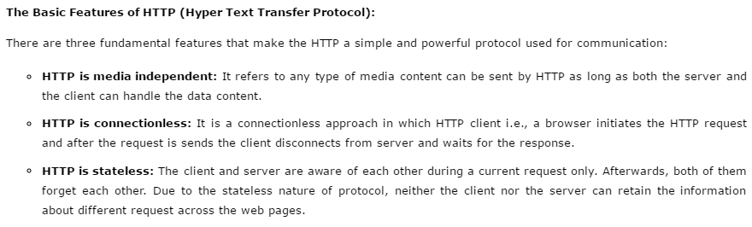

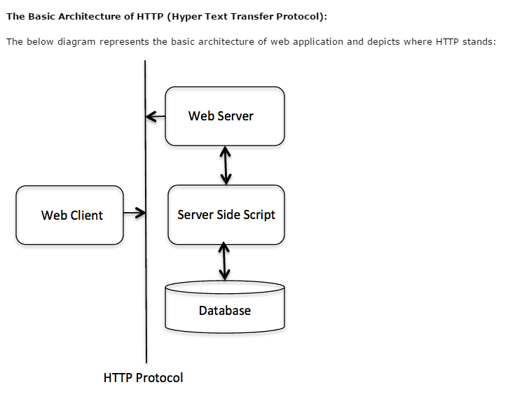

## **HTTP Requests->**

**The request sends by the computer to a web server that contains all sorts of potentially interesting information is known as HTTP requests.**

The HTTP client sends the request to the server in the form of request message which includes following information:

* The Request-line
* The analysis of source IP address, proxy and port
* The analysis of destination IP address, protocol, port and host
* The Requested URI (Uniform Resource Identifier)
* The Request method and Content
* The User-Agent header
* The Connection control header
* The Cache control header

The HTTP request method indicates the method to be performed on the resource identified by the **Requested URI (Uniform Resource Identifier)**. This method is case-sensitive and should be used in uppercase.

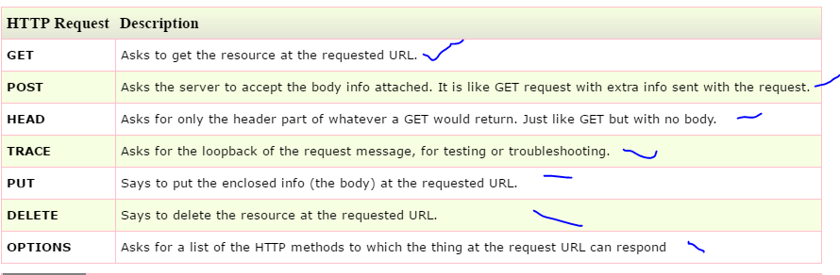

## **Get vs. Post->**

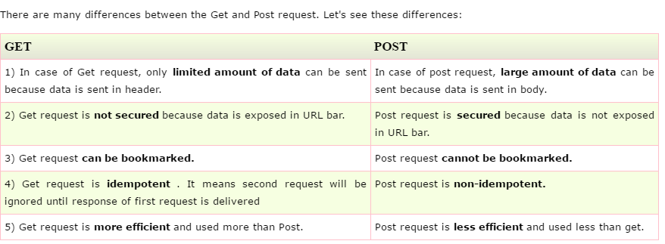

## **GET and POST->**

* **GET**- It requests the data from a specified resource
* **POST**- It submits the processed data to a specified resource

